This Analysis is poised at influencing decision making on this business to enhance growth and maximum revenue. We will investigate factors like the total revenue generated from the business, most effective payment methods, highest grossing revenue month, Active customers, Fraud transactions and other factors aiding or affecting growth.
The data was extracted from a relational database using SQL. You will then cleaned, transformed and validated in Microsoft Excel, ensuring accuracy, consistency, and readiness for analysis.
Finally, Power BI was used to model the dataset, create relationships, and develop calculated measures such as transaction volume, total revenue, average transaction value, customer activity trends, and fraud-risk indicators. These measures were used to design an interactive dashboard that visualized key fintech metrics across time, customer segments, payment channels, and geographic regions.
The below Questions were answered in the Analysis
- Which Month generates the most revenue and what merchant category was leading
- Which merchant category was leading across all months
- Which state generated the most revenue in each month and overall best performing state
- What is the top merchant category by state
- Which payment channel is most effective
- Which state and merchant category had the highest fraud rate
These questions would help us to arrive at reasonable business decisions that can enable growth
Answer No.1; Which Month generates the most revenue and what merchant category was leading 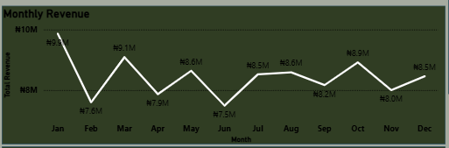
The line plot indicates that January is leading in monthly revenue
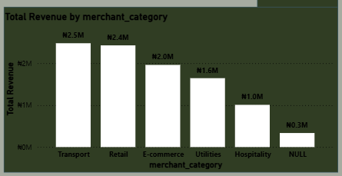
Moreover, by the merchant category in the month of January, Transport is leading. This suggests that we invest more in the Transport, retail and E-commerce sector over the month of January for better returns.
Answer No.2; which merchant category was leading across all months
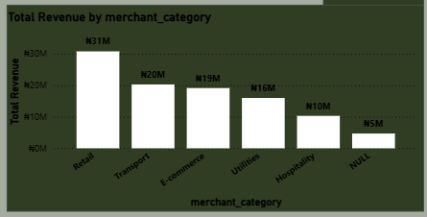
The bar plot suggests that retail generates by far more revenue than all categories
Answer No.3; which state generated the most revenue in each month and overall best performing state
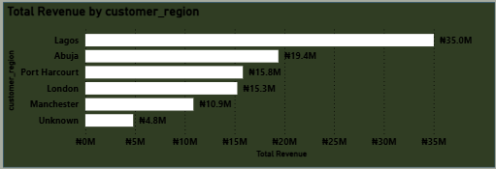
Referring back to the dashboard, we can see that Lagos state generated the most revenue across all months, making it by far a significant business hub for business growth.
Answer No.4; what is the top merchant category by state
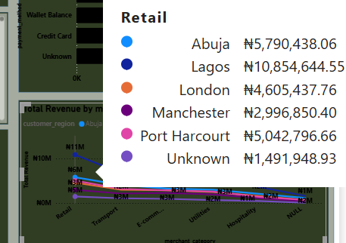
Retail is leading across all states, which indicates a high income in this category.
Answer No.5; which payment channel is most effective
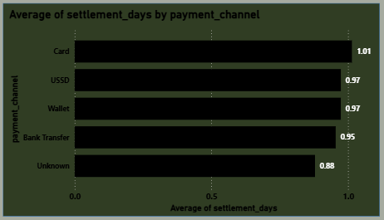
The payments which were unrecorded seemed to be the fastest method as it resulted to faster settlements
Answer No. 6; which state and merchant category had the highest fraud rate

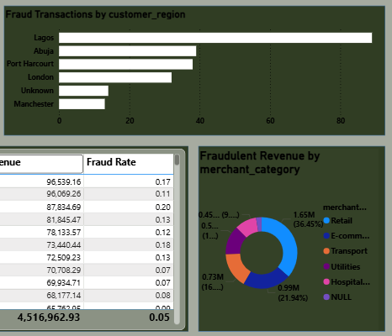
Lagos state by far leads in fraud rate and retail is the higher category with frauds. This suggests that in as much as we make a lot of money from Lagos state and retails, there have to be more checks and balances to curb the fraud rate. The higher the income/revenue, the more risk of fraud
Final Take: The general analysis suggests we;
- Keep record of all transaction payment method to enhance payment system and settlement days
- `Invest more in Transport in December/January(end of year) taking advantage of the season to ensure maximum profit
- Set up fraud detectors in high grossing states and categories to curb the fraud rate
- Make proper preparations for January traffic to enhance customer satisfaction; it is the highest grossing month and still has one of the lowest settlement days
- Given the relatively stable settlement performance and potentially lower transaction costs associated with USSD, there may be an opportunity to strategically increase adoption of this channel to enhance overall margin efficiency, subject to customer behavior and operational capacity considerations.

